1.(a)
 | 1 | 0
Q0 | Q2 | Q1
Q1 | Q4 | Q3
Q2 | Q3 | Q4
Q3 | Q5 | Q5
Q4 | Q5 | Q5
Q5 | Q5 | Q5
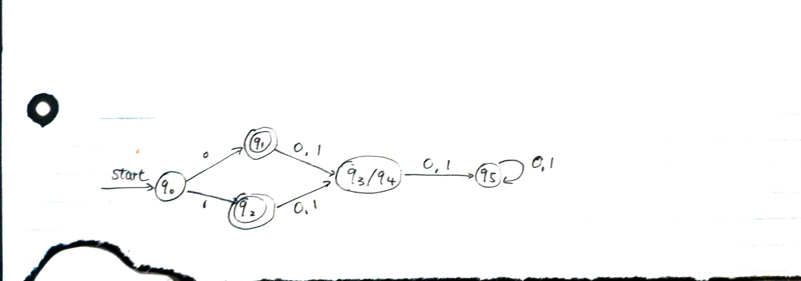
(b) L= {0, 1, 000, 001, 011, 010… 11111}
L= {w| w∈ (0+1)* | w!=2| |w|>2}

2. (a) L={0^n 1^m 0^n | m, n ≥ 0}
Assume L is a regular language.
If we consider n=3 m=1, then L = 0001000.
If we put L to three part and test three case 00|0|1000, so x =00, y =0, z = 1000.
Case 1: |y| >=1; |0|>=1, 1>=1;
True;
Case 2: |xy|<=P
|000|<=3+1+3
3<=7; true;
Case 3: check xy^i z for different value of i.
i=1:
00(0)^1 1000 = 0001000∈L
i=2:
00(0)^2 1000 = 00001000 ∉L
For 0^4 1 0^3 where n can not be both 4 and 3.
Failed.
So (a) is not regular language.

(b) assume L = {0^m 1^n | m != n}, and L is regular language. Set string S = 0^p 1^(p+p!). we separate S to three part x, y, z, so S = 0^p 1^(p+p!) = xyz∈L and |S|>=P where P is the pumping length.
Assume x = 0^i, y =0^j, z = 0^k 1^(p+p!), when j>=1 and i+j+k=P.
Now set string S’ = xy^(a+1)z, where a = P!/j.
Then y^a = 0^(p!), so y^(a+1) = 0&(b+p!), so xyz = 0^(p+p!)1^(p+p!).
We know m!=n, but xyz = 0^(p+p!)1^(p+p!). so xyz ∉ L.
It is not regular language.

(c) L =, and assume L is regular language.
Assume a String S = 0^P 1 0^P, and separate the string into three pieces x, y, z. so S = 0^P 1 0^P = xyz∈L where P is the pumping length.
Assume that x = 0^(P-k), y = 0^K and z = 10^P where K>0
Now xy^0 z = 0^(P-K)0^K 10^P = 0^(P-K) 10^P.
The string xy^0 z does not belong to L for P-K<P and wuw as in L.
So L is not regular language.

3. yes the language is regular.
Regular expression: (0+1)*

4. (a)
CFG: S -> 0S0|1S1|0|1| ε

(b)
CFG: S-> SASBS|SBSAS|ε
A->1;
B->0;

(c)
CFG: S->0S1|ε

5.
Set S in A.
CFG: S-> X|Y
X->A1C1
Y->A2C2
A1->aA1b|ε
C1->cC1|ε
A2->aA2|ε
C2->bC2c|ε
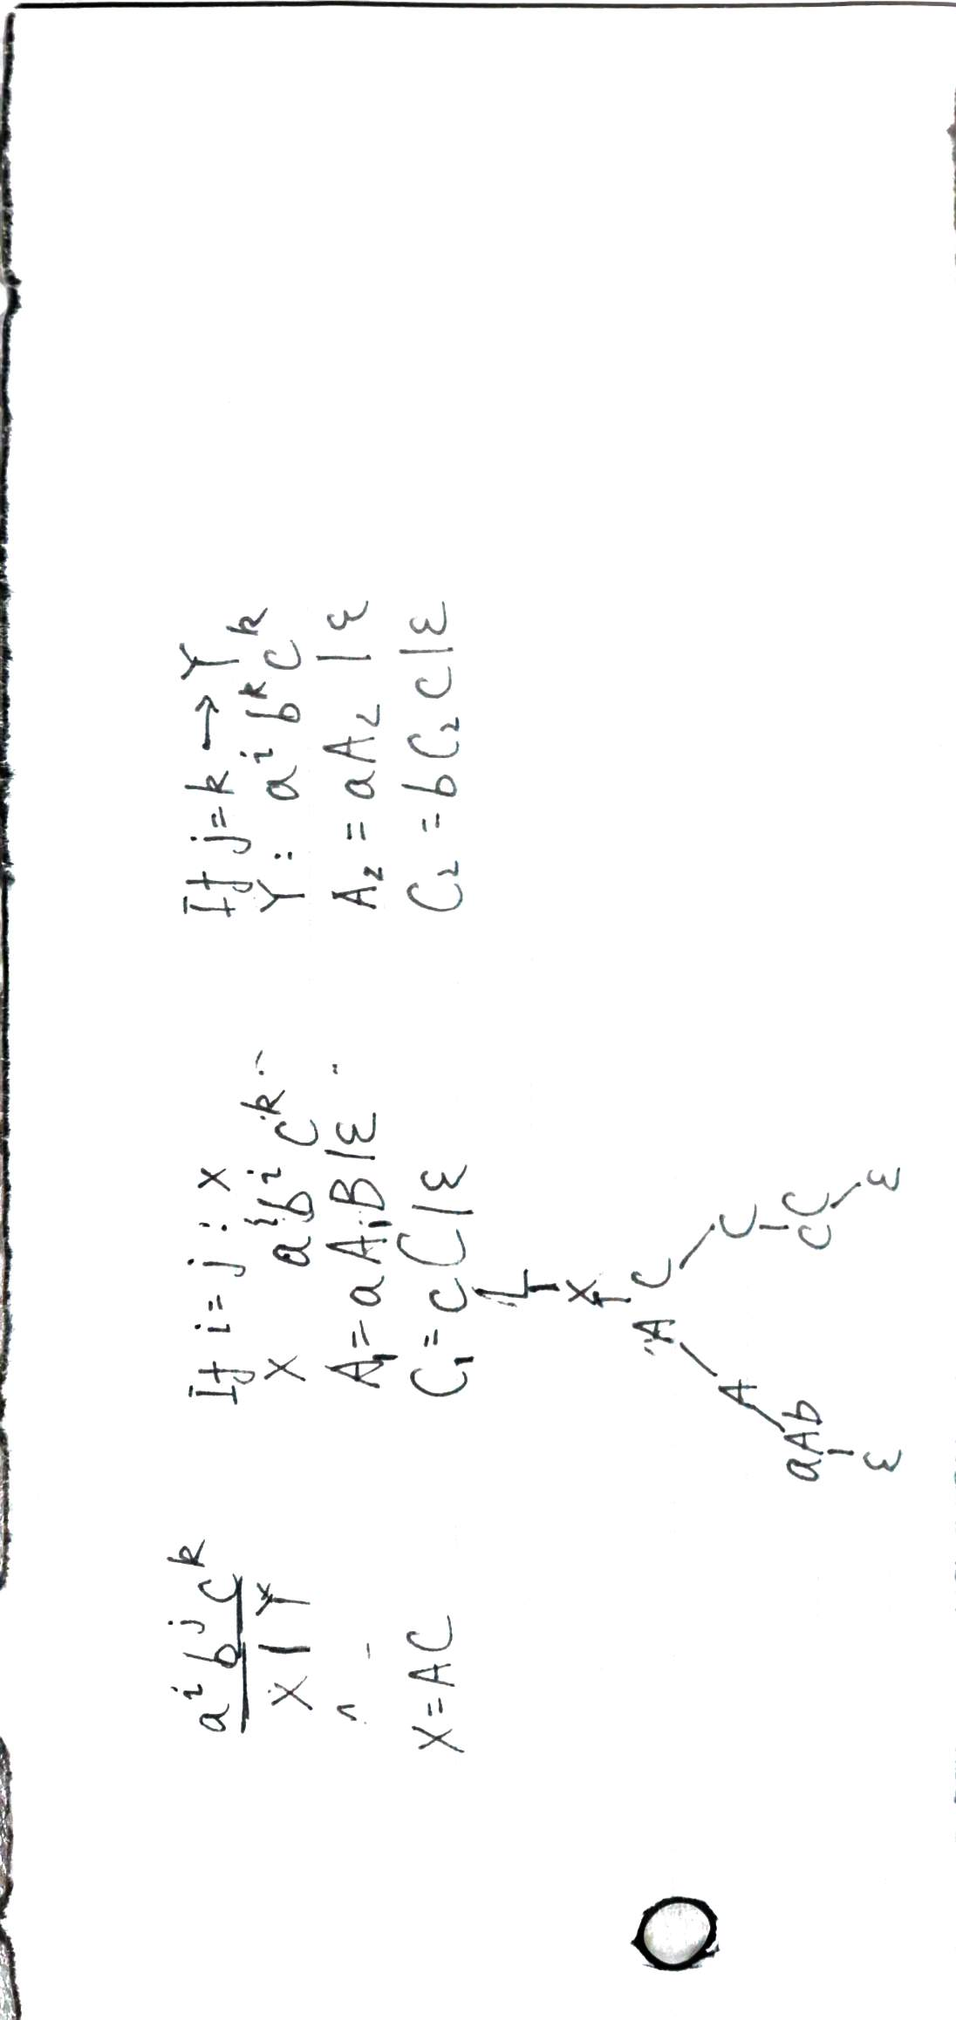
6. 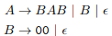
Step 1: add a new A0
A0->A
A->BAB|B|ε
B->00|ε
Step 2: remove null productions
A0->A
A->BAB|BA|AB|A|B
B->00
Step 3: remove unit production
A0->BAB|BA|AB|A|B
A->BAB|BA|AB|A|B
B->00
Step 4: set X = AB
A0 -> BX|BA|AB|B
A->BX|BA|AB|B
X->AB
B->00

(7) 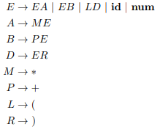

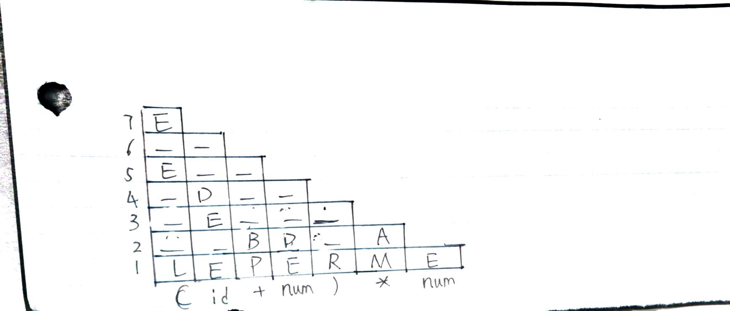
(8) No,
Here is counter example.
